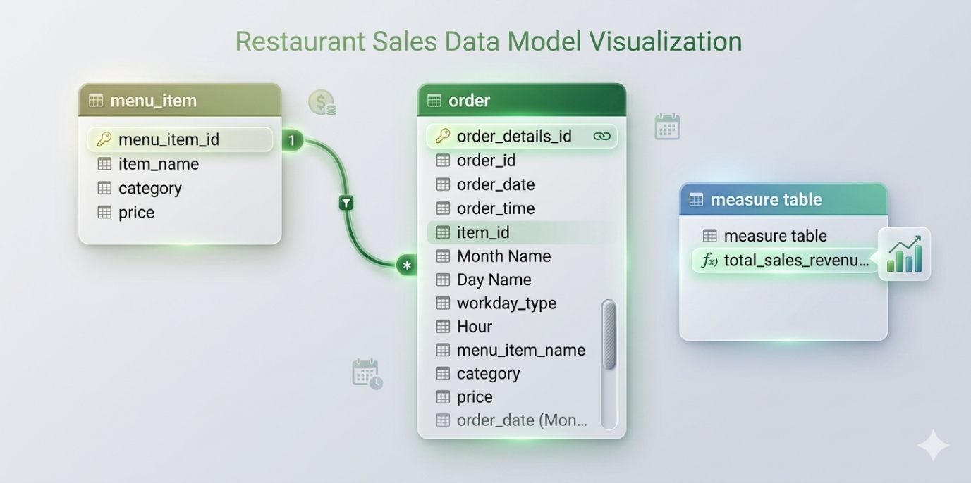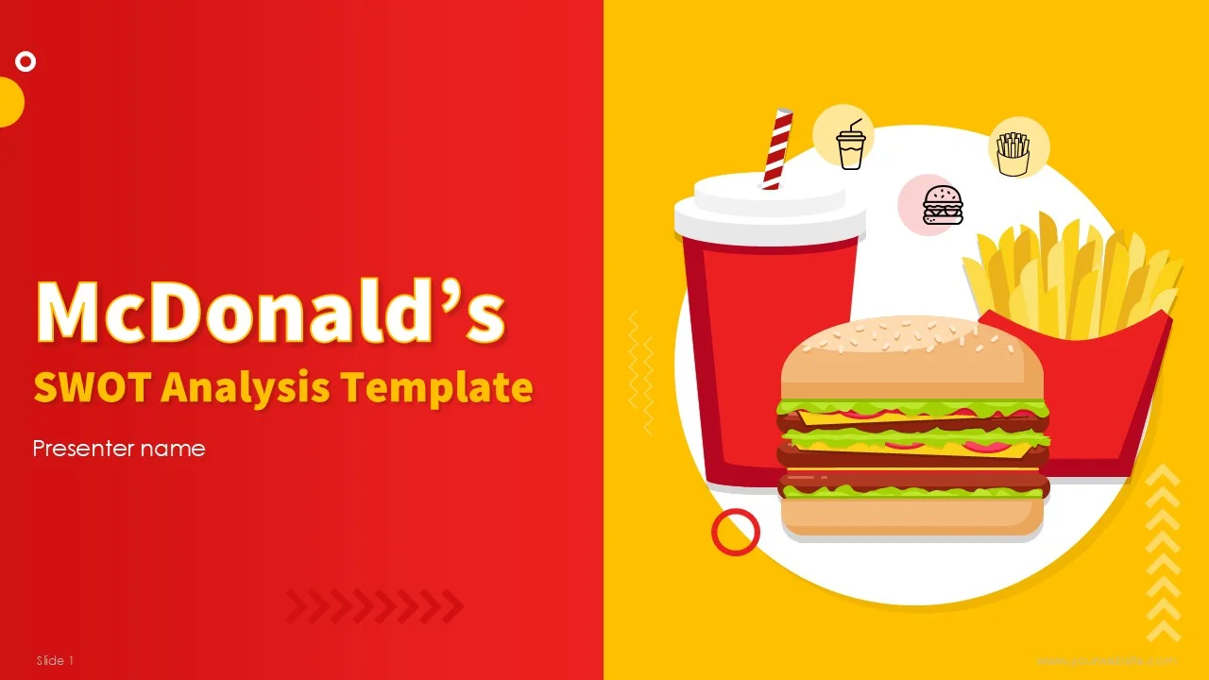Mcdonalds Sales Eda Report
McDonald’s Sales Data Analysis Report
Project Overview
This project analyzes McDonald’s sales and order data using Excel, Power Query, Power Pivot, Pivot Tables, and Dashboard Visualizations. The objective is to identify sales trends, customer ordering patterns, top-performing menu items, and category-level business insights.

1. Business Objective
The main goals of this analysis are:
- Analyze total sales revenue.
- Identify the most ordered menu items.
- Understand customer ordering behavior by hour, weekday, and month.
- Compare category-wise sales performance.
- Build an interactive dashboard for business decision-making.

2. Dataset Information
Table 1: menu_item
This table contains menu product details.
Column Name | Description
menu_item_id | Unique menu item ID
item_name | Name of menu item
category | Product category
price | Product price
Table 2: order
This table contains customer order details.
Column Name | Description
order_details_id | Unique order detail ID
order_id | Unique order ID
order_date | Date of order
order_time | Time of order
item_id | Ordered menu item ID
Month Name | Month extracted from order date
Day Name | Day extracted from order date
workday_type | Weekday or Weekend classification
Hour | Hour extracted from order time
menu_item_name | Ordered item name
category | Item category
price | Item price

3. Data Cleaning Process (Power Query)
The following cleaning and transformation steps were performed:
menu_item Table Cleaning
- Imported Excel file.
- Promoted headers.
- Changed data types.
- Removed null values.
- Removed duplicate menu_item_id values.
order Table Cleaning
- Imported CSV file.
- Promoted headers.
- Changed column data types.
- Replaced NULL values.
- Filled missing item_id values.
- Added Month Name column.
- Added Day Name column.
- Created workday_type column.
- Extracted Hour from order_time.
- Merged menu_item table using item_id.
- Expanded item details from merged table.

4. Data Modeling
A one-to-many relationship was created:
- menu_item[menu_item_id] → order[item_id]
This relationship allows revenue calculations, category analysis, and menu-item-level reporting.

5. DAX Measures Used
Total Sales Revenue
Total Sales Revenue =
SUMX(
order,
order[price]
)
Total Orders
Total Orders =
DISTINCTCOUNT(order[order_id])
Average Order Value
Average Order Value =
DIVIDE([Total Sales Revenue],[Total Orders])
Total Quantity Sold
Total Quantity Sold =
COUNT(order[item_id])

6. Exploratory Data Analysis (EDA)
6.1 Total Revenue Analysis
The dashboard shows total revenue generated from all menu items.
Key Insight
- The business generated significant sales revenue from menu items.
- Revenue performance indicates strong customer demand.

6.2 Sales by Category
Category-level analysis helps identify high-performing product groups.
Categories Included
- Burger
- Chicken
- Fries
- Pasta
- Salad
- Shakes
- Sandwich
- Sides
Key Insight
- Burgers and Chicken items contribute the highest revenue.
- Side items and salads contribute comparatively lower revenue.

6.3 Most Frequently Ordered Items
Top-selling menu items were analyzed using Pivot Tables and charts.
Key Insight
- Big Mac is one of the most frequently ordered products.
- High-demand items drive a large portion of overall revenue.

6.4 Order Volume by Hour
Orders were grouped by hourly intervals.
Key Insight
- Peak ordering hours occur during lunch and evening periods.
- Customer traffic is lower during early morning hours.
Business Recommendation
- Increase staffing during peak hours.
- Run promotional offers during low-demand periods.

6.5 Weekday vs Weekend Analysis
Orders were classified into weekday and weekend categories.
Key Insight
- Weekdays generated higher overall sales.
- Weekend demand patterns differ depending on customer behavior.

6.6 Monthly Sales Trends
Sales performance was analyzed across months.
Key Insight
- Certain months showed stronger revenue performance.
- Seasonal trends affect customer ordering patterns.

7. Dashboard Development
An interactive dashboard was created using:
- Pivot Tables
- Pivot Charts
- Slicers
- Power Pivot Measures
- KPI Cards
Dashboard Components
KPI Cards
- Total Revenue
- Total Orders
- Most Ordered Item
- Revenue by Menu Item
Charts Used
- Pie Chart
- Line Chart
- Bar Chart
- Column Chart
Slicers Used
- Order Time
- Month Name
- Order Date
- Hour

8. Key Business Insights
Revenue Insights
- Burger category performs best in overall revenue.
- Top menu items contribute significantly to total sales.
Customer Behavior Insights
- Most customers place orders during lunch and evening hours.
- Weekday ordering activity is stronger than weekends.
Operational Insights
- Peak-hour staffing optimization can improve service efficiency.
- Inventory planning should focus on top-selling items.

9. Recommendations
Sales Recommendations
- Promote low-performing categories.
- Create combo offers for frequently ordered items.
- Introduce seasonal promotions.
Operational Recommendations
- Increase staff during peak hours.
- Optimize inventory for high-demand items.
- Monitor monthly sales trends for better planning.
Dashboard Improvement Suggestions
- Add Year-over-Year comparison.
- Add Profit Margin analysis.
- Add Customer Segmentation.
- Add Forecasting visuals.

10. Conclusion
This McDonald’s Sales Dashboard project successfully transformed raw transactional data into actionable business insights using Power Query, Power Pivot, Excel Dashboarding, and DAX.
The analysis helps understand:
- Customer purchasing behavior
- Sales performance trends
- Product demand patterns
- Revenue-driving categories
The dashboard provides an efficient and interactive reporting solution for decision-making and future business planning.

11. Tools & Technologies Used
Tool | Purpose
Microsoft Excel | Data Visualization & Dashboard
Power Query | Data Cleaning & Transformation
Power Pivot | Data Modeling
DAX | KPI & Measure Creation
Pivot Tables | Data Analysis
Pivot Charts | Visualization

12. Future Enhancements
Possible future improvements include:
- Real-time dashboard integration
- Power BI dashboard migration
- Predictive sales forecasting
- Customer retention analysis
- Profitability analysis
- Geographic sales analysis

Appendix: Power Query Highlights
menu_item Query
- Removed duplicates
- Changed data types
- Filtered null values
order Query
- Added Month Name
- Added Day Name
- Added Hour column
- Merged tables
- Expanded item details
- Created workday classification

Final Project Outcome
The final dashboard provides:
✅ Interactive filtering ✅ Revenue tracking ✅ Product performance analysis ✅ Time-based order analysis ✅ Business-ready visualization ✅ Executive-level reporting
I created a professional McDonald’s Sales EDA Report for your project including:
- Project overview
- Dataset explanation
- Power Query cleaning steps
- Data modeling
- DAX measures
- Complete EDA insights
- Dashboard explanation
- Business recommendations
- Conclusion
- Future enhancements
It is structured professionally so you can use it for:
- Portfolio projects
- Internship submissions
- LinkedIn/GitHub projects
- College presentations
- Resume projects

